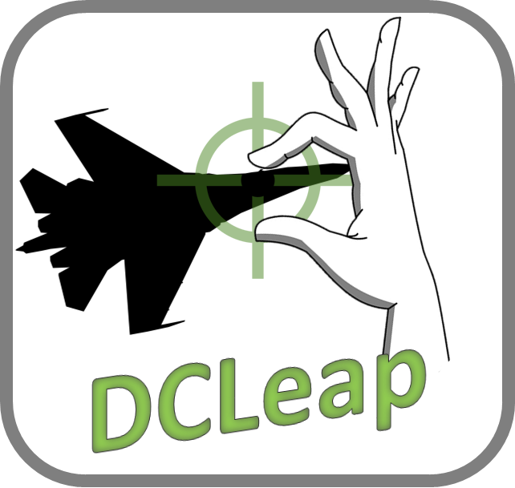

v 1.0

November 17th 2019

# Overview

DCLeap is a Windows application, running in background, to control the movements and events of the mouse and the achievement of specific actions related to the gestures of the hands, all in a virtual reality environment.

Although developed for DCS World, mouse operation with DCLeap remains usable for any other application, whether VR or desktop. However, gestural interactions are confined to an operation within DCS World.

**DCLeap is not compatible with Oculus devices.**

## DCLeap software and hardware

DCLeap is composed of :

* Mouse movement management module ;
* Module for managing events linked to the mouse (right and left clicks);
* Module for detecting interactions in the context of hand gestures.

DCLeap was developed in C # with Unity and uses the following solutions :

* Win32 C# mouse ;
* InputSimulatorPlus by TChatzigiannakis ;
* LeapMotion Core SDK for Unity ;
* LeapMotion Interaction engine for Unity ;
* OVRLay by BenOtter.

The prerequisites of DCLeap are:

* Virtual reality HMD ;
* Headmounted LeapMotion device ;
* DCS World ;
* SteamVR, beta or stable ;
* Drivers CBuchner *driverleap (*<https://github.com/cbuchner1/driver_leap>*)*;
* Drivers SDraw *driverleap* (<https://github.com/SDraw/driver_leap>)

## Installation

Starting from the premise that DCS World, SteamVR and the two "driverleap" are already installed, unzip the DCLeap.7z archive to the location of your choice.Dès lors, ouvrez l’exécutable DCLeap.exe.

At the first use, it is necessary to enter the resolution of a single screen of your VR headset, for example:

* WMR :1440 x 1440 ;
* HP Reverb : 2160 x 2160 ;
* HTC Vive Pro : 1440 x 1600.

Once filled in, click “Save Settings” button.

It is imperative to perform this step because DCLeap will recover two registry keys containing the specified resolutions in order to generate the cursor movements.

This registration in the registry is the only entry generated outside the folder in which you unpacked DCLeap.

These registry keys are under:\Computer\HKEY_CURRENT_USER\Software\Leap4DCS\DCLeap

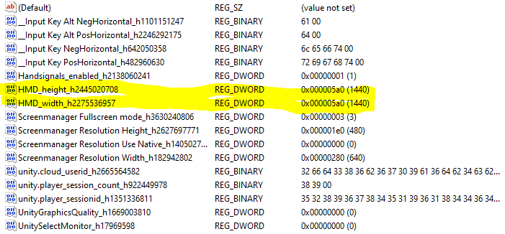

Check the creation of these keys by launching Regedit via the Windows command prompt (Win + R key).

If the keys are generated correctly and the associated values ​​are correct, run the DCLeap.exe executable.

Normally, the entered values ​​should be italicized in the input fields. You should see the Unity window below, make sure the windowed mode is enabled, and then click "Play! ".

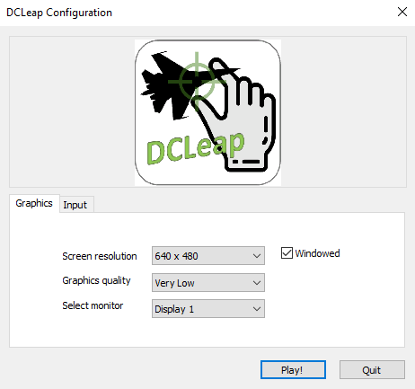

# Usage

## Main Menu

When DCleap is launched, you will access this window, Main Menu, where you can ;

* Enable the gesture recognition feature ;
* Allow hand signals;
* Allow texts popup ;
* Define click method by allowing pinch and/or index trigger gesture;
* Define the sensitivity of the pinch gesture ;
* Define the knob sensitivity;
* Define mouse sensitivity ;

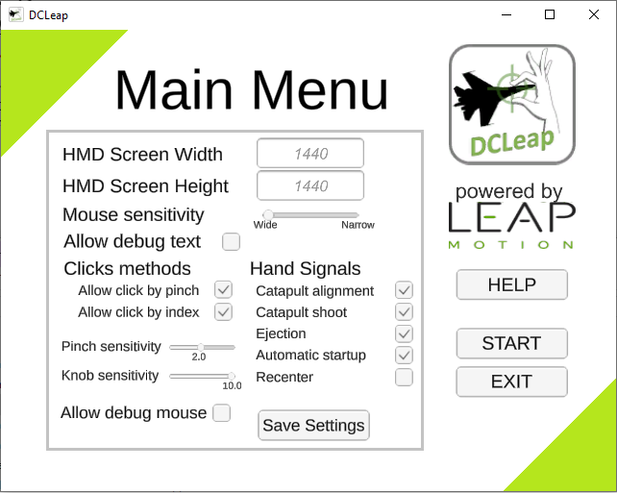

## Help Menu

From this window you can access help reminding the different gestures implanted.

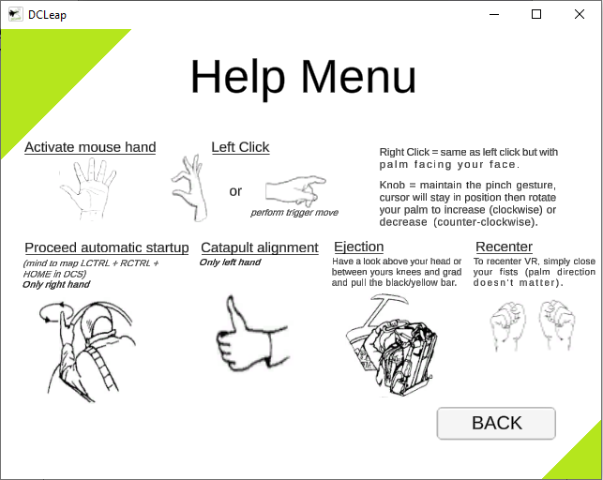

Note that you’ll have to define LCTRL+RCTRL+HOME in DCS Configurator command Automatic Startup to perform automatic startup and XXXX

## Start Button

Once you have pressed the Start button, you should see two red and green squares appearing in your RV headset, indicating the activation of the virtual mouse.

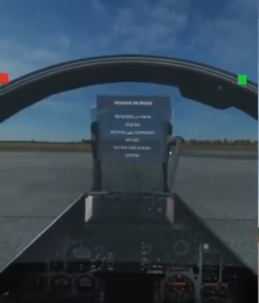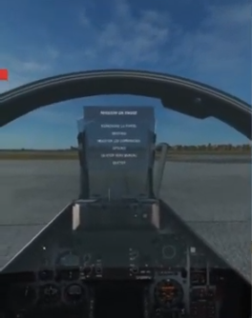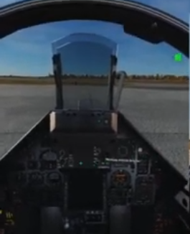

Figure 1 – From left to right - both hands move the mouse, only the left hand, only the right

The red square indicates that the mouse control is slave to the hand, left, the green square indicates that the control is slaved to the right hand. In order to avoid any disruption related to activation of both hands tracking, it is best to assign mouse tracking to one hand at a time.

DCLeap will tell you when right click is available as shown under.

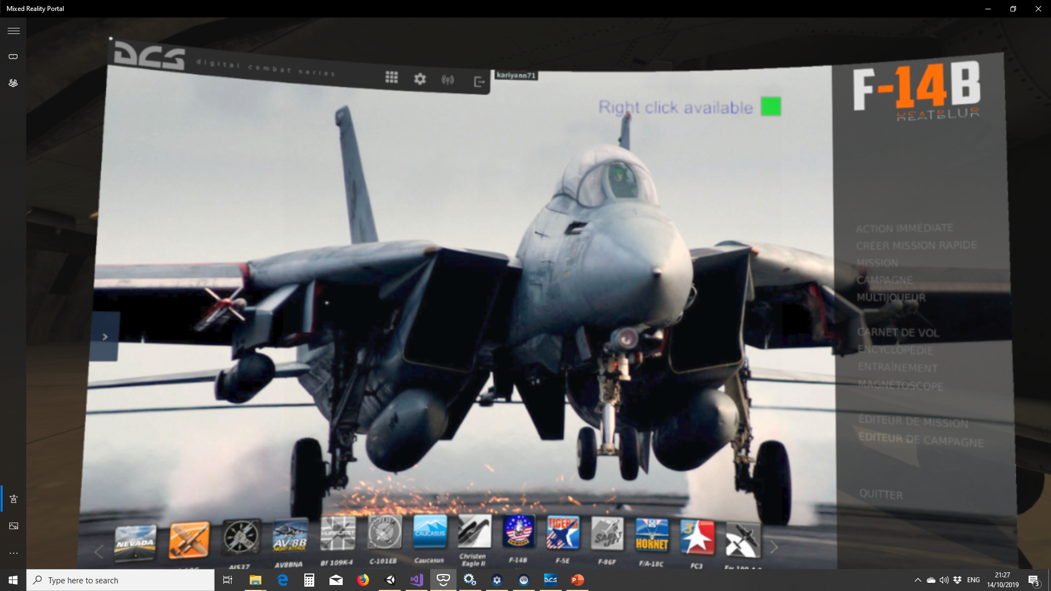

### Catapult shoot

DCLeap allow you to execute catapult shootwith the salute gesture. Currently this action is mapped to LShift + U.

When you execute “Salute” you will see “Catapult Shoot !” in red letters on top right of your HMD (if Allow debug text is ticked in the Main Menu).

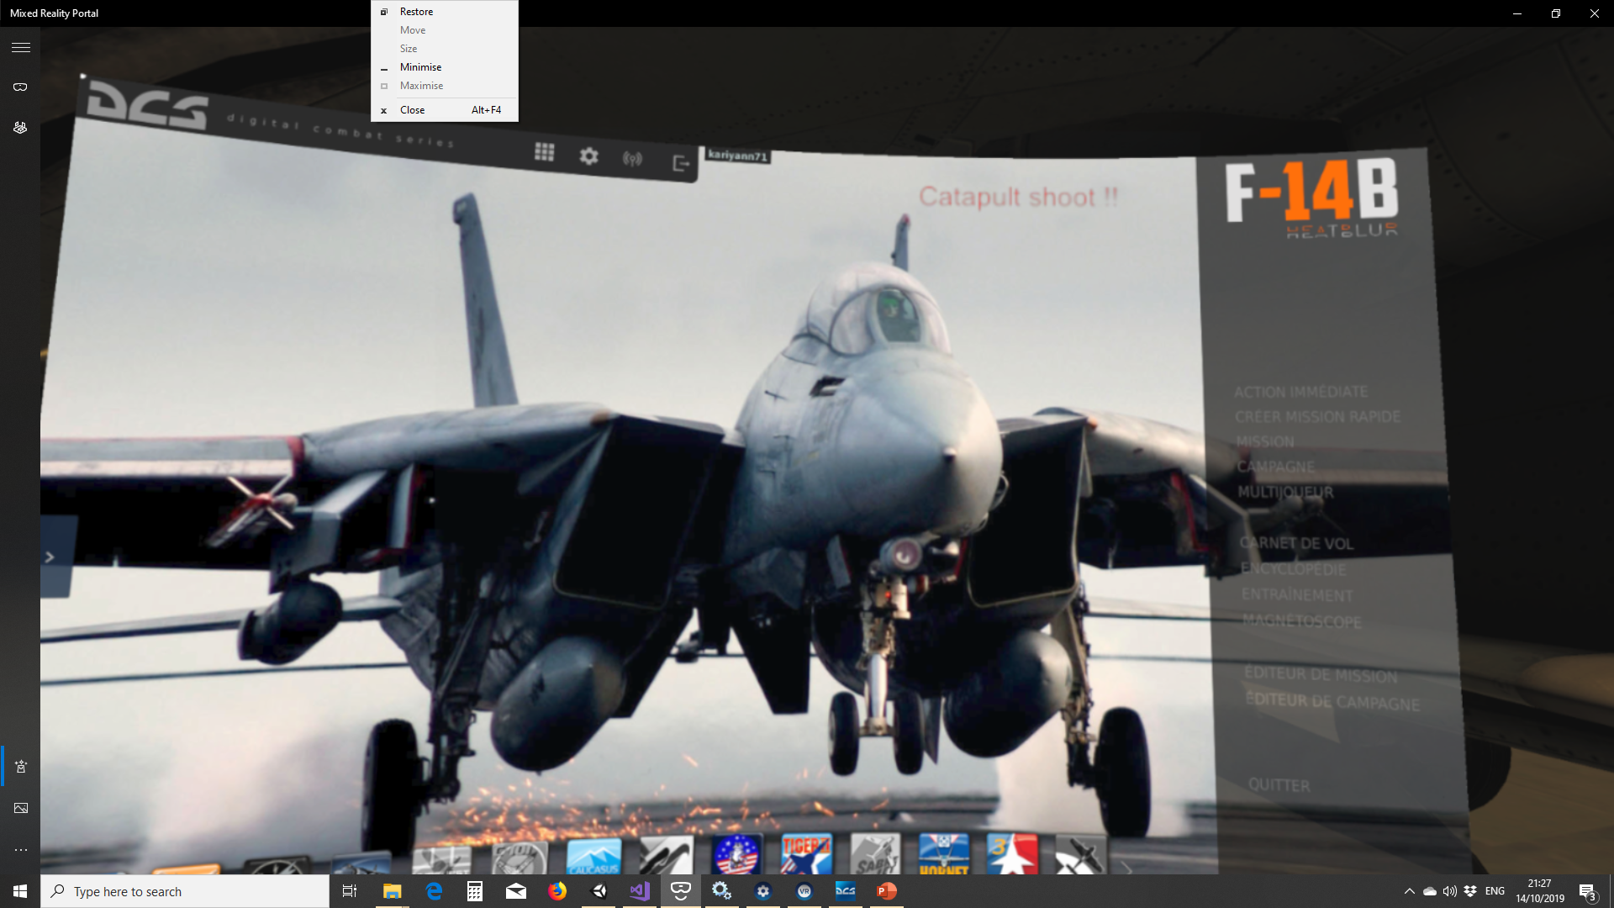

### Catapult align

You can align your aircraft to catapult (Keyboard U) with Thumb up gesture. As for catapult shoot, you will see “Catapult Align” in red letters (if Allow debug text is ticked in the Main Menu).

### Start-Up

### Recenter VR view

### Ejection

## Quit

To exit the application, Alt+Tab to get DCLeap on foreground, then press the Esc key and then click on the "Quit" button.

Other, DCLeap automatically quit when SteamVR is shutdown.

# To go further

## Pinch gesture

Here is the illustration under Unity of the pinch gesture zone (the red one) and the release pinch zone (the blue one).

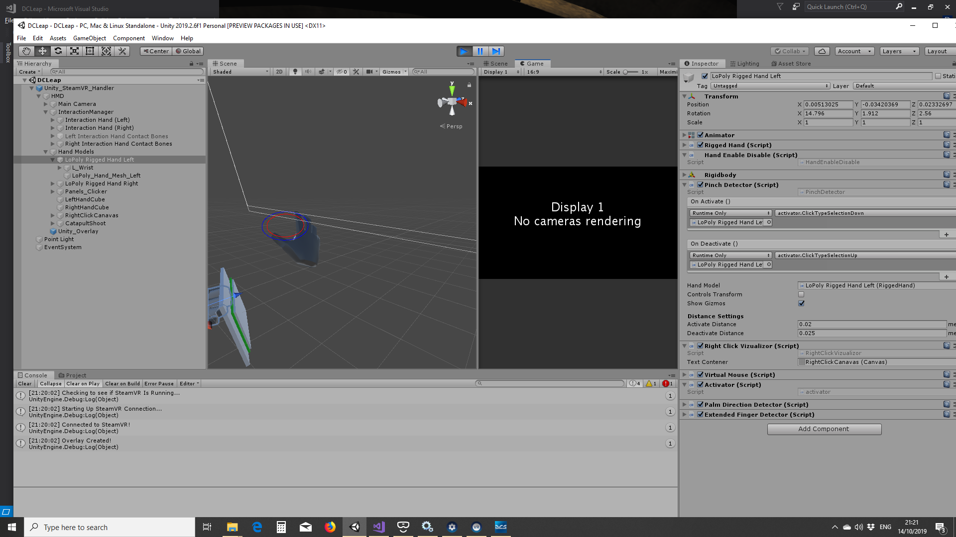

## Palm facing zone

When the white line (line between the HMD and the palm) enter in the red cone, LeapMotion detect your hand is facing your head. Currently the red cone is set at 45°.

